

HTML

HTML NOTE

RAHUL KUMAR | HTML NOTE | 02-10-2022

# INTRODUTION TO HTML

HTML IS MARKUP LANGUAGE THAT WEB BROWSERS USE TO INTERPRET AND COMPOSE TEXT,IMAGES AND OTHER MATERIAL INTO VISUAL OR AUDIBLE WEB PAGES

* IT’S HYPER TEXT MARKUP LANGUAGE
* IT’S EASY TO LEARN
* IT’S A LANGUAGE TO CREATED WEB PAGES
* IT’S NOT PROGARMING LANGUAGE, WHICH ITS MENAS IT HAS NO DECISION CONTROL. HTML HAS MARKUP TAGS TO DEFINES ELEMENTS OF THE PAGES AND STRUCTURE OF THE PAGE.
* IT’S MARKUP TAGS ARE USUALLY CALLED HTML TAGS
* YOU CAN DESIGN A STATIC WEB PAGES WITH THE HELP OF HTML
* YOU NEED TO INSTALL ANY TEXT TEXT EDITOR(LIKE NOTE PED, VS CODE) TO WRITE HTML CODE AND ANY WEB BROWSER (LIKR CHROME) TO RUN THE CODE.
* HTML FILES ARE SAVED WITH THE EXTENSION .html
* HTML IS CASE INSENSITIVE LANGUAGE
* HTML IS DEVELOPED BY WORLD WIDE WEB CONSORTIUM
* CUUSING USING HTML 5
* TO LEARN HTML YOU NO NEED PROGARMING BACKGROUND
* **YOU NEED TO OPEN NOTE PED , VS CODE OPEN A NEW FILE AND WRITE HTML CODE IN IT. SAVE IT WITH .html EXTENSION. EXCUTE IT WITH SOME BROWSER. YOU CAN REOPEN HTML FILE WITH NOTEPED OR VS CODETO MAKE ANY EDITION.**

## HTML ELEMENTS

* AN HTML ELEMENT IS AN INDIVIDUAL COMPONENT OF HTML DOCUMENT
* ITS STARTS WITH A START TAG / OPENING TAG AND ENDS WITH AN END TAG / CLOSING TAG
* THE ELEMENT CONTENT IS EVERYTHING BETWEEN THE START AND THE END TAG
* MOST HTML ELEMENT CAN HAVE ATTRIBUTES

EXAMPLE

<P> THIS IS HTML CODE </P>

HERE <P> IS A STARTING CODE AND </P> IS CLOSING TAG.

EVERING BETWEEN THEM IS PARAGRAPH CONTENT & DISPLAYED ON BROWSER;

DOCMENT STRUCTURE ELEMENTS

<html>

The root element of an HTML document ; all other elements are contained in this

The HTML element delimits the beginning and the end of an HTML document

<head>

Container for processing information and metadata for an HTML document

<body>

Container for the displaying content of an html document

HTML DOCUMENT FORMAT

<html >

<head>

    <!-- Place processing information and metadata here -->

</head>

<body>

    <!-- Place displayable content here -->

</body>

</html>

COMMENTS

<!-

Write your comment here

-->

Like this

 <!-- Place processing information and metadata here -->

TITLE TAG

It’s written in <head> tag

The <title> tag defines the title of the document

It defines a title in the browser toolbar

Tt providers a title for the pages when it is added to favorites

It display a title for the pages in search – engine results

<html >

<head>

    <title>Welcome</title>

</head>

<body>

</body>

</html>

HEADING TAGS

Heading are defined with the <h1> to <h6> tags

<h1> defines the most important heading.

<h6> defines the least important heading.

Search engines use your heading to index the structure and content of your web pages

<html >

<head>

    <title>Welcome</title>

</head>

<body>

    <h1>Heading 1</h1>

    <h2>Heading 2</h2>

    <h3>Heading 3</h3>

    <h4>Heading 4</h4>

    <h6>Heading 5</h5>

    <h6>Heading 6</h6>

</body>

</html>

PARAGRAPH TAG

Paragraph are defined with the <p> tag

Browsers automatically add an empty line before and after a paragraph.

We can gives by default keyword are be used in Lorem by default we can recived 30 words

We want to more than word so we can using LoremXXXX. Where XXXX is any number.

<html >

<head>

    <title>Welcome</title>

</head>

<body>

    <h1>Paragraphs</h1>

    <p>Welcome to web technology class</p>

</body>

</html>

Formatting tags

Use the <br/> tag if you want a line break (a new line ) without starting a new paragraph

The <br/> element is an empty HTML element

It has no end tag.

The <hr /> tag creates a horizontal line in an HTML page.

The <hr /> element can be used to separate content.

<html>

<head>

    <title>Welcome</title>

</head>

<body>

    <h1>Paragraphs</h1>

    <p>Welcome to web technology class</p> <br>

    <hr>

    <p>Welcome to web technology class</p> <br>

</body>

</html>

Output

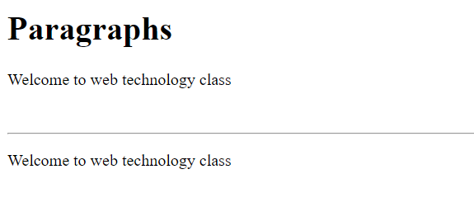

IMAGE TAG

Images are defined the <img> tag.

General syntax:

<img src="" alt="">

Note: After src we can mention the path of the images.

After alt we can mention error mention

    <img src="./download.jfif" alt="Error the pic">

Output

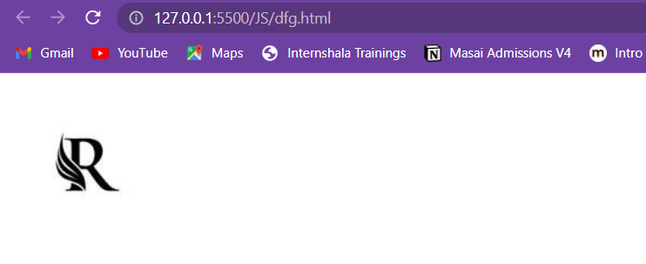

<img src="" alt="Error the pic">

Output

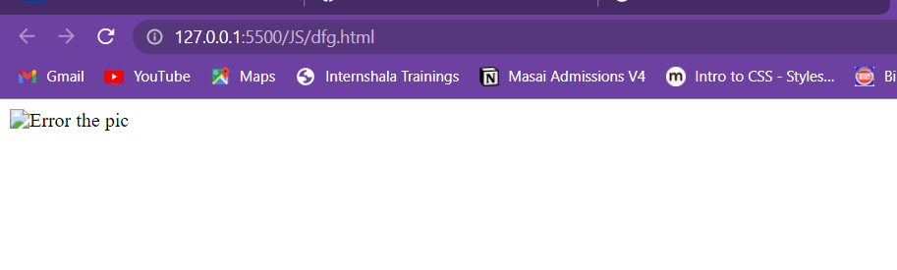

The <img> tag is empty, which means that it contains attributes only, and has no closing tag.

To display and image on pages, you need are attribute . scr stands for “source”. The value of the src attribute is the URL of the image you want to display.

ATTRIBUTES OF IMAGE TAG

|  |  |
| --- | --- |
| ATTRIBUTES OF IMAGE TAG | |
| Scr | Some url for image |
| Alt | Alternative text |
| Width | pixel or percentage |
| Height | pixel or percentage |
| Align | top,bottom,middle,left,right |

THE DEFAULT ALIGNMENT IS BOTTOM i.e the text surrounding the image will appear at bottom of the image

Border :- The **border**  attribute places a border around the image. Value is in pixel.

    <img src="./download.jfif" width="200" height="150" alt="Error the pic">

    <img src="./download.jfif" alt="Error the pic">

    <img src="./download.jfif" border="1">

Output

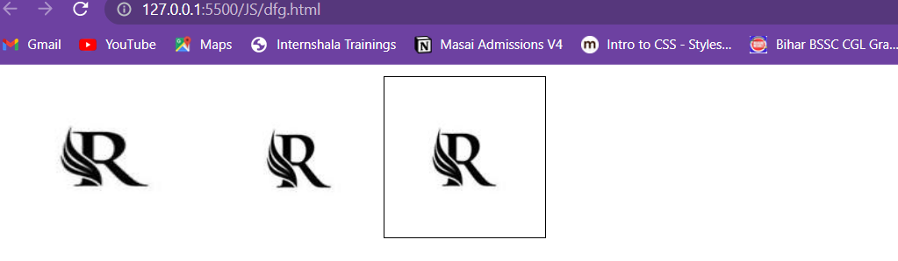

LIST TAG

List are used to group related pieces of information together, So they are clearly associated with each other and easy to read.

Two type:-

1. Unordered List – used to group a set of related items, in no particular order.

An unordered list starts with the <ul> tag.

Each list item starts with the <li> tag.

The list items are marked with bullets(typically small black circles).

By default mark as bullets.

<html>

<head>

    <title>Welcome</title>

</head>

<body>

    <ul>

        <li>HTML</li>

        <li>CSS</li>

        <li>JS</li>

    </ul>

</body>

</html>

Output:

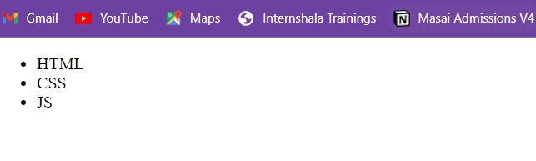

Attribute type:

By default unordered lists appear with bullets.

But if required then we can change this symbol to “square” or “circle”

Square

Disc

Circle

Like this

  <ul type="square">

        <li>HTML</li>

        <li>CSS</li>

        <li>JS</li>

    </ul>

1. Ordered List

Ordered list or numbered lists are used to display a list of items that need to placed in a specific order

The <ol> tag is used to create an order list.

The list can be numerical or alphabetical.

 <ol >

        <li>HTML</li>

        <li>CSS</li>

        <li>JS</li>

    </ol>

Attribute Type

By default ordered lists appear with numbers.

But if required then we can change number to letters or roman numbers

To do this we need to handle “type” attribute of <ol> tag.

Attribute type has following values

1

A

I

a

i

Like this

<ol type="i">

        <li>HTML</li>

        <li>CSS</li>

        <li>JS</li>

    </ol>

ANCHOR TAG

A hyperlink (or link) is a word, group of words, or image that you can click on to jump to a new document or a new section within the current document.

Links are specified in HTML using the <a> tag.

Syntax

<a href="url">link text</a>

Example

<html>

<head>

    <title>Anchor example</title>

</head>

<body>

    <a href="./Indiaflag.html">Click Here</a>

</body>

</html>

Table Tag

<table> defines a table

<th> defines a table header

<tr> defines a row in a table

<td> defines table data

Attributes of table tag

* Border :- it specifies the width of the border around a table
* Cellpadding:_ specifies the space between the cell wall and the cell content
* Cellspacing:- Specifies the space between cells
* Align :_ value can be left , center or right
* Bgcolor :- specifies a background color of the a table
  + Color name(“pink”)
  + Hex code of color name(“#ffA000”)
  + Rgb number(“rgb255,0,0”)
* Width :_ specifies the width of a table

Attributes of <th> and <td> tags

|  |  |
| --- | --- |
| ATTRIBUTES OF <th> and <td> tags | |
| align | left , right , center , justify |
| bgcolor | color name , rgb() ,hex code |
| colspan | number |
| rowspan | number |
| height | pixel or percentage |
| valign | top , middle , bottom |
| Width | pixel or percentage |

Example

<html>

<head>

    <title>Anchor example</title>

</head>

<body>

    <table border="5px" cellspacing="0px">

        <tr bgcolor="khaki">

            <th>S.No</th>

            <th>Name</th>

            <th>Age</th>

        </tr>

        <tr>

            <td>1</td>

            <td>Rahul rai</td>

            <td>22</td>

        </tr>

        <tr>

            <td>2</td>

            <td>Rahul kumar</td>

            <td>21</td>

        </tr>

        <tr>

            <td>3</td>

            <td>Chandan</td>

            <td>20</td>

        </tr>

    </table>

</body>

</html>

Output

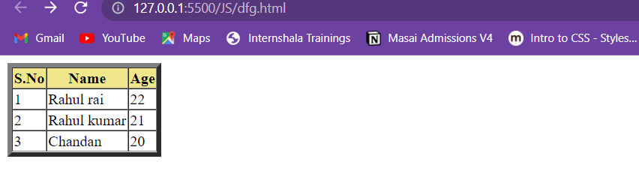

BLOCK AND INLINE ELEMENT

In visual browsers, displayable element can be rendered as either block or inline

Block element have automatic break line feature.

Inline element do not have automatic line change feature.

Example

Block element: paragraph , heading , list etc

Inline element: image , anchor etc.

DIV AND SPAN TAG

DIFINES A SECTION IN DOCUMENT <div>

<DIV></DIV>

**DIFIENES A SECTION IN DOCUMENT <span>**

<span></span>

**The difference between span and div is that a span element is in-line and usually used for a small chunk of in-line HTML whereas a div (division) element is block- line (which is basically equivalent to having a line break- break and after it) and used to group larger chunks of code.**

**FORM TAG**

**HTML forms are used to pass data to a server.**

**A form can contain input elements like text fields, checkbox, radio-buttons, submit buttons and more.**

**A form can also contain select lists , textarea, fieldset, legend, and label elements.**

**The most important form element is the input element**

**To create an HTML form we use the <form> tag.**

**Syntax:**

    <form action="">

        <!-- input controls -->

    </form>

**Attributes of form tag**

* **Action**
  + **The required action attribute specifies where to send the form- data when a form is submitted.**
* **Method**
  + **Specifies how to send send from-data.**
  + **The form – data can be sent as URL variables(with method=”get”) or as HTTP post (with method=”post”)**

**Example**

<html>

<head>

    <title>Form example</title>

</head>

<body>

    <form action="SumServlet" method="get">

        <!-- input controls -->

    </form>

</body>

</html>

**Tags within form tag**

**<input>, <button>, <option>, <select>, <textarea>**

**Input tag**

**The input element is used to select user information**

**An input element can vary in many ways, depending on the type attribute.**

<input type="text" />

        <input type="submit" />

        <input type="radio" />

        <input type="password" />

**TEXTAREA TAG**

**THE <textarea> tag defines a multi-line text input control.**

**A text area can hold an unlimited number of characters.**

**The size of a textarea can be specified by the cols and rows attributes, or even butter; through CSS’ height and width properties.**

**SELECT AND OPTION TAGS**

**The <select> tag is used to create a select list(drop-down list).**

**The <option> tags inside the select element defines the available in the list.**

**BUTTON TAG**

**The <button> tag defines a push button**

**Form Example( for better alignment element related to form resides inside the table tag)**

<html>

<head>

    <title>Form example</title>

</head>

<body>

    <form action="RegistrationServlet" method="post">

        <form action="RegistrationServlet" method="post">

            <table>

                <tr>

                    <td>Name</td>

                    <td> <input onkeyup="fun1()" type="text" name="user" /></td>

                    <td id="msg1"></td>

                </tr>

                <tr>

                    <td>Password</td>

                    <td> <input type="password" name="pwd" /></td>

                </tr>

                <tr>

                    <td>Gender</td>

                    <td><input type="radio" name="gender" />M

                        <input type="radio" name="gender" /> F</td>

                </tr>

                <tr>

                    <td>Course</td>

                    <td><input type="checkbox" name="HTML" />HTML

                        <input type="checkbox" name="CSS" />CSS</td>

                </tr>

                <tr>

                    <td></td>

                    <td><input type="submit" onclick="return validate()" value="Register" />

                        <input type="reset" /></td>

                </tr>

            </table>

        </form>

</body>

</html>

**Output**

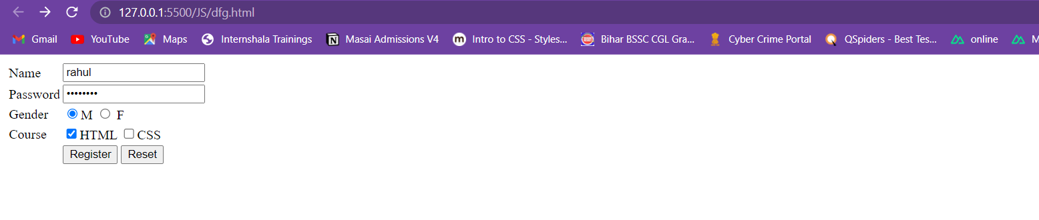

In the above HTML code , as soon as user presses the submit button, form data will send to the Server. Data will be send to a server so that it can get processed there. The Java script or PHP script that will used the data is mentioned in action attribute of form tag.